Title [Times New Roman 16, IN BOLD, CENTERED, IN CAPITAL LETTERS]

Name Surname
Author’s affiliation, country
Name Surname
Author's affiliation, country

Abstract. Abstract text, please check here to learn about how abstract should be written and follow these rules. The draft abstracts can be about 1/4 -1/2 page long (80-150 words), in English only. The abstract includes Problem Statement, Purpose of Study, Methods, Findings and Results, and Conclusions and Recommendations (These elements may need some adaptation in the case of discussion papers: Background, Purpose of Study, Sources of Evidence, Main Argument, and Conclusions). Please note that some elements are optional in abstracts.
The text must be presented in accordance with the requirements. Page size is A4, text should be in one column, in single line spacing, left margin – 25 mm, right margin – 25 mm, top margin – 25 mm, bottom margin – 25 mm. Do not use special characters, symbols or mathematical characters in the title and the abstract. Font: Times New Roman, in italics, font size 12 pt.
Keywords: keywords in alphabetical order, not longer than 2 lines, in English only.

Introduction

This document shows the suggested format and appearance of a manuscript prepared for ERCS journals. Please try to follow Recommended Structure: Introduction. Literature review (cite here as many sources as possible), Data and methodology, Results and Discussion, Conclusions, Acknowledgements (if any), References. In separate cases, due to specificity of research, the structure may slightly differ (for instance, in manuscripts devoted to literature analysis).
This template provides the authors with the most of the formatting specifications needed for preparing electronic versions of their papers. Introduction should include topicality of the subject, the study aims and methods. Font: Times New Roman, font size 14 pt.
If a manuscript is in Latvian or Russian, all the titles (the title of a manuscript, titles of sub-chapters, titles of tables and figures) should be translated into English.

Literature review

A review of previous studies is provided. The layout: font Times New Roman, font size 14 pt; the titles of the chapters shall be highlighted in Bold and centred. All figures, tables and other objects must be numbered and placed in line with the text. If a manuscript is in Latvian or Russian, its title shall be written in both the original language and English.
The quoting takes place according to the requirements of publishing guidelines (Volume 6) of American Psychological Association (APA Style) (see https://owl.english.purdue.edu/owl/resource/560/01/). All references mentioned in the Reference List are cited in the text, and vice versa. Please use APA Style and follow the author-date method of in-text citation. This means that the author's last name and the year of publication for the source should appear in the text, for example, (Jones, 1998), and a complete reference should appear in the reference list at the end of the paper. If it is a work by two authors, in-text citation is the following: (Wegener & Petty, 1994). In cases, when a work is written by three to Five Authors, use only the first author's last name followed by "et al." in the signal phrase or in parentheses, for example (Kernis et al., 1993).
APA style has a series of important rules on using author names as part of the author-date system. There are additional rules for citing indirect sources, electronic sources, and sources without page numbers. APA Style guidelines are available at https://owl.english.purdue.edu/owl/resource/560/01/
Article has been 'spell checked' and 'grammar checked'

Data and methodology

Research participants (a set of respondents), data acquisition and processing methods are characterized, if required – research setting or limitations are specified.

Results and Discussion

Results should be clear and concise. Tables and figures make the results section clearer. The purpose of tables and figures in documents is to enhance your readers' understanding of the information in the document. Figures and tables should be referenced in the text. Tables and figures are numbered. Their titles are in Times New Roman, font size 12 pt; the titles of the figures shall be highlighted in Bold and centred.
In preparing figures, communication and readability must be the ultimate criteria. Avoid the temptation to use the special effects available in most advanced software packages. Design properly done is inconspicuous, almost invisible, because it supports communication.

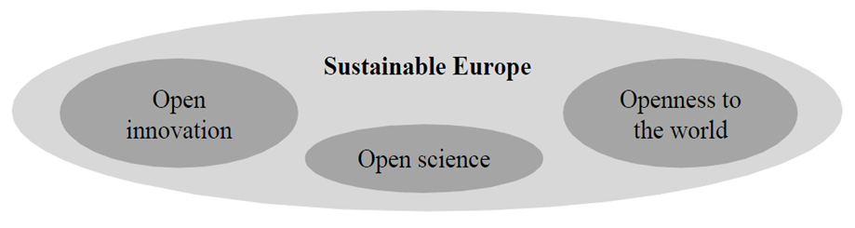
Figure 1. Three strategic priorities for sustainable European future

The table design: caption above the table, font Times New Roman, font size 12pt. the titles of the table shall be highlighted in Bold and centred.

Table 1 Course attendance by country (Kruskal-Wallis test)

Type of courses | p | Mean Rank
 |  | Greece | Italy | Latvia | Poland | Spain
English | .000 | 125.19 | 163.24 | 182.6 | 103.8 | 91.76
Specific course for profession | .000 | 121.51 | 156.86 | 163.03 | 134.57 | 91.77
Culture | .000 | 127.47 | 168.32 | 180.26 | 101.61 | 88.18
Other | .000 | 123.23 | 171.87 | 183.88 | 97.99 | 89.99

When including statistics in written text, be sure to include enough information for the reader to understand the study. Although the amount of explanation and data included depends upon the study, APA style has guidelines for the representation of statistical information:
- Do not give references for statistics unless the statistic is uncommon, used unconventionally, or is the focus of the article
- Do not give formulas for common statistics (i.e. mean, t test)
- Do not repeat descriptive statistics in the text if they’re represented in a table or figure
- Use terms like respectively and in order when enumerating a series of statistics; this illustrates the relationship between the numbers in the series.
Discussion should explore the significance of the results of the work, not repeat them. A combined Results and Discussion section is often appropriate. Avoid extensive citations and discussion of published literature.

Conclusions

The main conclusions of the study may be presented in a short Conclusions section, which may stand alone or form a subsection of a Discussion or Results and Discussion section.

Acknowledgements

Place acknowledgements before the references, in a separate section, and not as a footnote on the title page.

References

The references are arranged in the alphabetic order; in the beginning, there are the sources in Latin letters, afterwards - in Cyrillic. The references are made according to the requirements of publishing guidelines (Volume 6) of American Psychological Association (APA Style) (see https://owl.english.purdue.edu/owl/resource/560/01/ ).

